Julian Diego Y. Bautista
XII – Generosity

Lego Labandero Laundry Shop

Nowadays, it is very difficult for families or homes to hire trustworthy and hardworking helpers. This results to them resorting to establishments or businesses to do their chores for them. One of which includes doing laundry which tends to get very hectic and hassle for people most of the time due to consistent visits to laundry shops with piles of clothes. With busy schedules and workload, sometimes, people can barely do their chores.

Though there are already a lot of laundry shops, this one is purposely located in one subdivision only, and is open only to its residents. This way, tasks may be done faster for customers are only exclusive to those who reside in the subdivision. The process of this business will be through creating a facebook page. Residents of Don Jose subdivision will message the page regarding their names, phone numbers, and addresses and the staff will claim their clothes from their homes and also deliver them back when they’ve already been cleaned.

I chose the location Don Jose Subdivision because it is very big and is resided along the highway. Due to this, residents really have to go in and out of the subdivision, and onto the busy, polluted streets just to be able to get their laundry done. It would be very convenient to have a laundry shop inside the subdivision, purposely for its residents. The objectives in establishing this business include the following:

Mission
- to establish a business that helps people in a certain community or vicinity accomplish daily tasks faster and instantly

Vision
- to use technology in a way that is convenient to people and at the same time make profit out of it

Goals
- to disregard travel time for people in the vicinity getting their laundry done, most especially those who are busy and always on the go
- for people in the area to have their clothes washed instantly any time, especially during clutch events
- to fill in the needs for those who find it difficult to hire helpers that are efficient enough

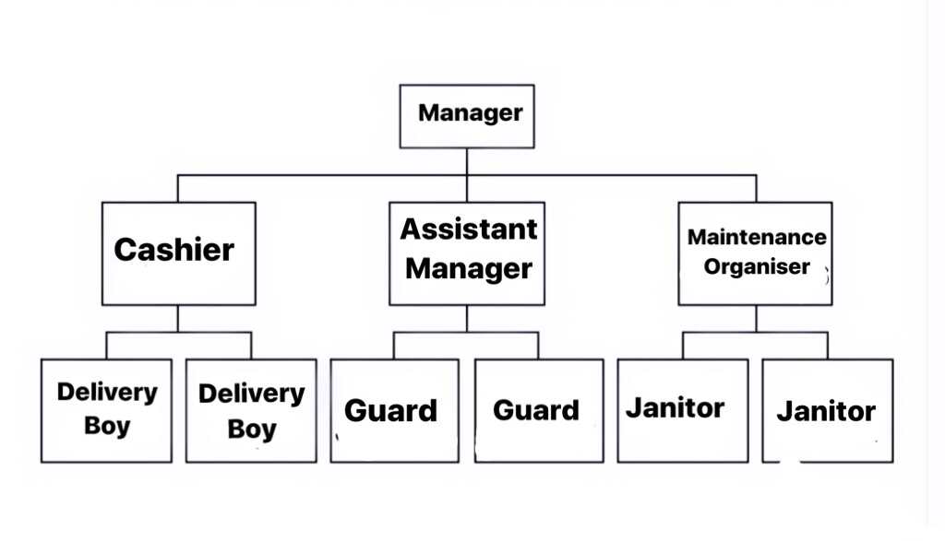

ORGANIZATION STRUCTURE

