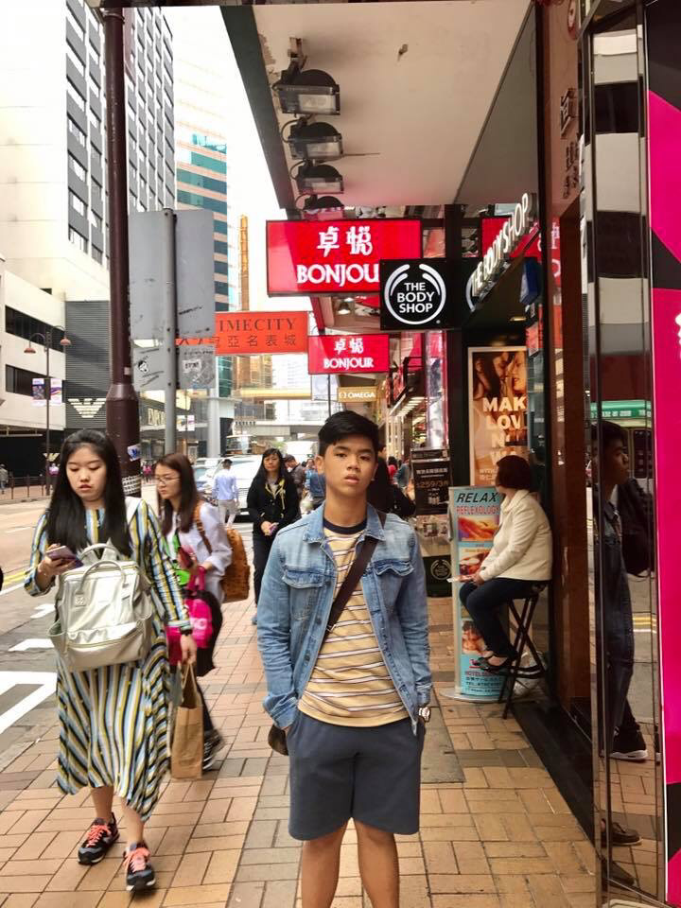
Julian Diego Y. Bautista
XII- generosity

Laptop Lifestyle Travels: Hong Kong

As the plane descended I looked out the window and saw nothing but clouds. I was hoping for a view of Hong Kong during our descent, but it wasn’t until we were just about to touch down on the tarmac did we finally break through the clouds, or should I say, foggy-haze.
This was my first trip to Hong Kong. I read over some of the short wikipedia history and knew to expect mostly people of Chinese ethnicity, but as I would clearly learn the Hong Kong people feel very much different and independent from the mainland Chinese.
Hong Kong, as a once colony of Britain, is fairly easy to navigate because English is a main language. Cantonese is clearly the first language, especially given the far greater majority of native Hong Kong people speak it primarily, but you can find English signs on everything and most people speak some English.
Despite the language comfort, I was still wary about finding my away around. I like knowing my surroundings, so a first time visit to a place is always challenging.
The “Warp Speed” Taxi Ride
I was told by my Uber driver in Sydney on the way to the airport, who had visited Hong Kong several times, that the train system is very easy in Hong Kong. As a result, I briefly considered hopping on the MTR (train) from the airport after touching down in the evening.
I quickly changed my mind when I envisioned myself wandering down the dark streets of central Hong Kong with my phone maps not working. I decided a taxi was the way to go, even though I knew the price would be far more. I was hungry and tired and just wanted to be at the hotel.
As I started looking for a taxi rank, a random guy at the airport walked up to me and said “taxi?”. I refused and kept walking on, figuring that an official taxi rank was a smarter choice.
I eventually found a more official looking taxi waiting area, took a guess that I needed a “red” taxi and then patiently waited. I boarded an old, cluttered taxi, driven by a small man wearing a bandana. I gave him the address and off we went.
As I stared out the window looking at a very dark and hazy Hong Kong, the taxi driver started flying along. When I say flying – I mean warp speed.
We hit a long stretch of freeway and the guy must have been going at least 140km, taking over all the other cars and even going faster than what looked like a speedy train.
At one point the driver took out some money and started counting it with his hands, using his elbow to steer the wheel. Clearly not the safest technique. I said a little prayer.
Despite the insane speed, it took about 45 minutes, through two tolls and many bridges before we finally arrived in a city area, and thankfully slowed down due to traffic congestion.
It was at this point I decided to say something to my driver to make chit chat. His English wasn’t great, but he did manage to tell me I was in a “white person” area and also near party streets, pointing to a bar and then gesturing with his hands that it was a topless bar (I’ll let you use your imagination to figure out what kind of gesturing he did).
We pulled up at my hotel. I waited for the meter reading total – almost $350 HKD – I found a $500 to pay the man, he gave me change and quickly sped off. I headed to check-in.
My hotel room was small, but modern and more than adequate. The bed was fantastic, and the internet reliable. I booked my accommodation using trip advisor as a source of reviews, so I expected good things.

